**Name: salini k.b**

**Roll No:33**

**Batch:mca-b**

**Date:**

**NETWORKING & SYSTEM ADMINISTRATION LAB**

**Experiment No.: 1**

**Aim**

Tcp Filter Expressions

**1]Procedure**

sudo tcpdump -i enp3s0 -c 5 port 80

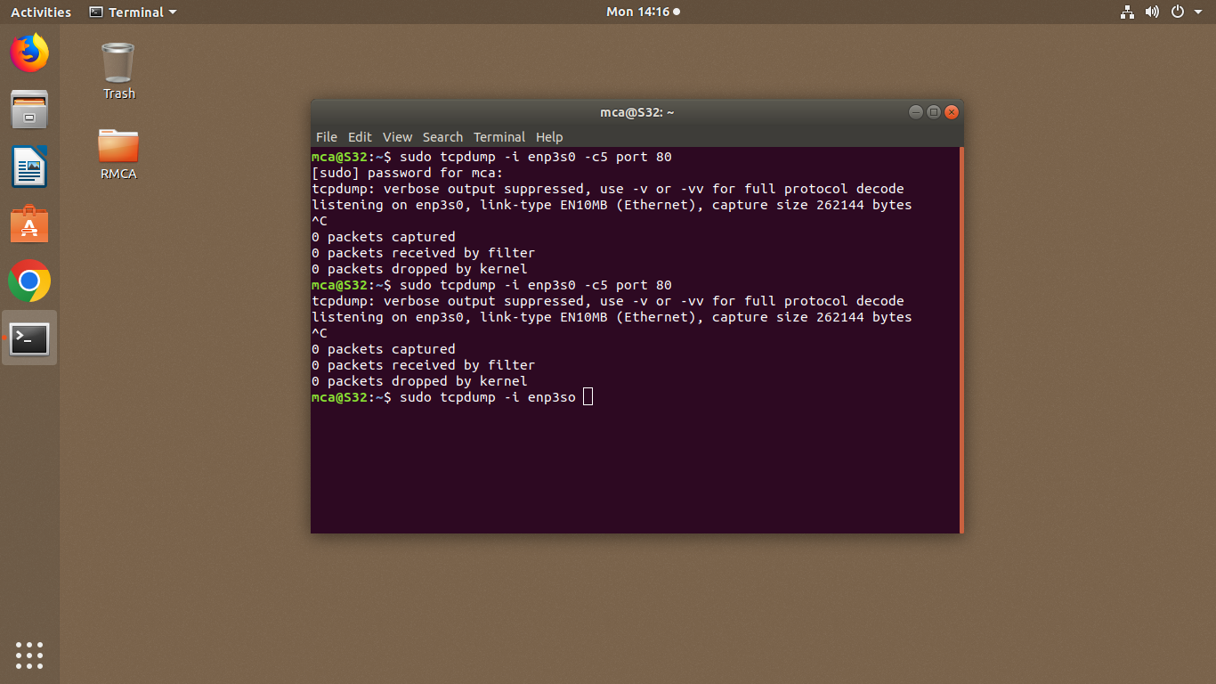

To capture all packets leaving and arriving

**Output Screenshot**

**2]Procedure**

sudo tcpdump -i enp3s0 icmp

packets using particular protocol

sudo tcpdump -i enp3s0 -c 10 -w icmp.pcap

following command saves 10 lines of output on the enp3s0 interface to icmp.pcap

**Output Screenshot**

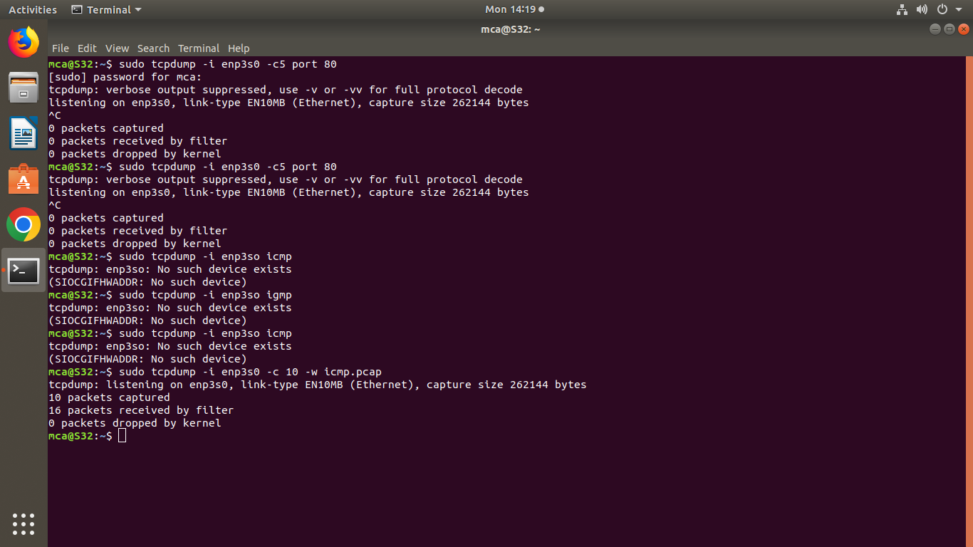

**3]Procedure**

sudo tcmpdump -r icmp.pcap

read those 10 lines

**Output Screenshot**

